Hexbot Script Compiler
Table of Contents
1.1 Hexbot Script Compiler 1
1.1 Introduction 1
1.2 Goals 1
1.3 Risks 1
1.4 Implementation Constraints 1
1.5 Overview 2
1.6 Command Set 3
1.7 Data Structures 5
1.8 Methodologies 5

Introduction

This document is a description of one possible design for a compiler that simplifies the creation and processing of scripts that describe leg movements of the Hexbot robot. This is an early draft, and is subject to major revision or rejection.

Goals
- reduce the amount of effort needed to create the scripts that define robot movements known as flows
- speed up the development of movement scripts, which is currently labour intensive.
- shift the mathematical calculations to the compiler
- to provide feedback on errors or dangerous behaviour in scripts
- allow the flow designer to work in higher level operations, such as “move the robot 3 cm forward” or “tilt 10 degrees to the left” rather than numeric coordinates for toes
- provide plug in points for other related functionality such as script validation, visualization, simulation
- provide a way to embed flows in the robot source code

Risks

- Complex math required to produce output script will be difficult to debug
- Incorrect numeric output may go undetected
- dependence on MQTT.fx and it’s file format

Implementation Constraints

This utility needs to run in the Windows and Mac environments, on the same platforms that run MQTT.fx. To achieve portability, it will be written in C++ and developed within the Microsoft Visual Studio Code framework which is currently used for the robot software environment.

Overview

This diagram describes the role of the compiler and the related utilities and files that are currently foreseen.

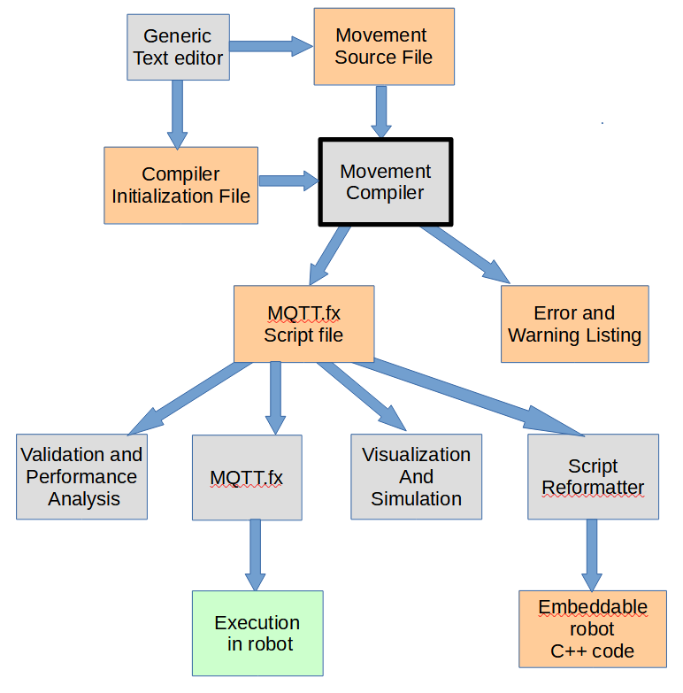

Generic text editor | A simple editor for unformatted text such as Notepad++
Movement Source File | The file containing commands to the compiler, one per line
Compiler initialization file | A simple text file containing compiler commands that is executed before compilation begins. Contains robot ID, compilation options, etc
Movement compiler | The C++ program that processes the movement source file and creates an equivalent MQTT.fx script file, and a list or errors and warnings
MQTT.fx script file | A standard, complete MQTT.fx script file that can be downloaded to a robot without further processing
Error and Warning Listing | A list of exception detected by the compiler
Validation and performance analysis | Future software that will analyze a script to detect inappropriate behaviour or measure the expected performance
MQTT.fx | The existing MQTT.fx client software
Visualization and simulation | Future software produces a graphical display of a script’s results
Script reformatter | Software that translates the script produced by the compiler into a format that allows it to be embedded in the robot source code
Execution in robot | The result of using MQTT.fx to download the compiled script into the robot, and execute it
Embeddable robot C++ code | A version of the script that can be added to the robot source so it can be executed immediately without downloading via MQTT.fx.

Command Set

Commands are at the beginning of the line and are terminated by a space character
Commands and arguments are not case sensitive.

// | Comment that is passed through to script
Leggroup a,1,2,3 | Define a group of legs, represented by a letter, that all get the same commands
Tilt bearing, degrees | Defines a tilt for robot to achieve.  - Bearing is a number from 0 – 359, 0 means straight forward, 90 means to the robot’s left...  - degrees is the tilt from vertical. 1 degree is a slight tilt towards the bearing
Tiltinc BearingInc, DegreesInc, count | Defines a tilt for robot to achieve.  - Bearing is a number from 0 – 359 representing the adjustment to the bearing made on each doit command  - DegreeInc is the adjustment added to the tile on each doit command  - count is the number of doit commands to repeat this command over
MoveAbsoluteGlobal leg, x, y, z | Prepare to move leg (which can be a leg number or a leggroup) to the absolute global coordinates x, y and z.
MoveAbsoluteLocal leg, x, y, z | Prepare to move leg (which can be a leg number or a leggroup) to the local coordinates x, y and z.
MoveRelHomeGlobal leg, x, y, z, count | Prepare to move leg (which can be a leg number or a leggroup) to the location which is the home position adjusted by x in the GLOBAL x direction, by y in the GLOBAL y direction and by z in the GLOBAL z direction.
MoveRelHomeLocal leg, x, y, z, count | Prepare to move leg (which can be a leg number or a leggroup) to the location which is the home position adjusted by x in the LOCAL x direction, by y in the LOCAL y direction and by z in the LOCAL z direction. Do this for each of the next “count” doit commands. Count defaults to 1
MoveRelLastGlobal leg, x, y, z, count | Prepare to move leg (which can be a leg number or a leggroup) to the location which is the LAST position for the leg adjusted by x in the GLOBAL x direction, by y in the GLOBAL y direction and by z in the GLOBAL z direction. Do this for each of the next “count” doit commands. Count defaults to 1
MoveRelLastLocal leg, x, y, z, count | Prepare to move leg (which can be a leg number or a leggroup) to the location which is the LAST position for the leg adjusted by x in the LOCAL x direction, by y in the LOCAL y direction and by z in the LOCAL z direction. Do this for each of the next “count” doit commands. Count defaults to 1
Rotate leg, degrees, count | Prepare to move leg (which can be a leg number or a leggroup) by rotating it through “degrees” maintaining its radius from robot’s center, global (0,0,*). Do this for each of the next “count” doit commands. Count defaults to 1
VerticalDisplace cm, count | Move center of robot up or down by cm centimeters. (up and down by changing global Z coordinate, not along tilt axis.) Do this for each of the next “count” doit commands. Count defaults to 1
Pause | Prepare to have the robot pause in place for the time given in the next doit command
Doit msec | Calculate all the move, tilt, and vertical displacement changes to toe positions, and write out the appropriate command to the output file.
SetOutputOperation | Tell the compiler what operation parameter should be used in the flow commands it outputs to the file. This will affect the numbers that are output as well.
CycleStart name | Indicate the beginning of a named subsection of the flow that will be repeated via an ExecuteCycle command later
CycleEnd name | Indicate the end of a named subsection of the flow that will be repeated via an ExecuteCycle command later
ExecuteCycle name, count | Repeat a named subsection of the flow for a number of repetitions
End | Indicates the end of the source file

Notes:
-idea of spreading an action over a bunch of commands, like:
- change tilt bearing by -10 degrees for each of next 18 doit commands
- move forward 1 cm on each of next 10 doit commands
- move forward a total of 12 cm, spread over the next 8 doit commands
-handy output to help in script development, like
- output position of leg 1’s toe in local coordinates until further notice
- control what goes in output listing
- all source lines, plus errors or warning lines
- generated toes positions in some format (carefully formatted for readability)
- display how close each toes gets to safety box (which we’d have to define somehow)
- display how close each toes gets to hitting part of chassis
- or only display above 2 bits of info if danger distance is less than some criteria
- output listing to file, or to console

Data Structures

The compiler needs to track the following data in order to be able to operate:

LastPosnGlobal X [legs] // flags to say if this has been initialized, or is undefined.
LastPosnGlobal Y [legs]
LastPosnGlobal Z [legs]

LastPosnLocal X [legs]
LastPosnLocal Y [legs]
LastPosnLocal Z [legs]

NewPosnGlobal X[legs] // keep internal positions in global coords, and translate to local as needed?
NewPosnGlobal Y[legs]
NewPosnGlobal Z[legs]

. . .

Methodologies
Support routines
- translate global coords to local
- translate local coords to global
- 2D vector rotation?
- leg group lookup

Order of Operations
- treat pause as a special case – set a flag, & generate error on any movement commands
- init NewPosnGlobal to LastPosnGlobal after doit done
- update NewPosnGlobal as move commands are encountered
- save details of rotate command until doit
- save details of vertical displace until doit
- save details of tilt until doit time
- need persistent data (over doit commands) for any command with a count parameter
- parameter change ( tilt bearinginc & tiltinc, vertical displace, rotation
- iterations remaining counter
-when doit encontered
-start with moves accumulated in New Posn Global
-apply tilt (one time, or repeated)
-apply rotation (one time or repeated)
-apply vertical displace (one time or repeated)
-do safety checks for safety box, and chassis collisions
-generate output coords arrays according to appropriate operation
-generate and output the flow command
- use a lot of flags to detect unexpected command combinations & orders, and use them to generate error
and warning messages

